DECODELABS
Industrial Training Kit — Batch 2026
Project 3: SQL Data Analysis
Querying for Truth — E-Commerce Orders Database
Prepared by: Data Analyst Intern
Date: July 2026

1. Problem Statement
DecodeLabs' order database holds 1,200 transactions across seven products, five payment methods, and five marketing channels. Business stakeholders don't need raw rows — they need specific, aggregated answers: which products earn the most, which channels convert best, and where fulfillment is breaking down.
This project answers those questions using pure SQL: filtering with WHERE, sorting with ORDER BY, bucketing with GROUP BY, and summarizing with COUNT, SUM, and AVG — the same declarative toolkit that powers every production reporting pipeline.

2. Methodology
All queries were run against a SQLite database (orders.db) built from the 1,200-row order export, using the engine's logical execution order:
FROM → WHERE → GROUP BY → HAVING → SELECT → ORDER BY
This matters in practice: a column alias created in SELECT (step 5) cannot be referenced inside WHERE (step 2), because the engine hasn't computed it yet. Every query below was written with this execution order in mind, not the order it's typed in.
- 39 queries were written, organized into 7 sections (A–G): basic SELECT, WHERE filtering, ORDER BY sorting, GROUP BY bucketing, aggregation (COUNT/SUM/AVG), HAVING, and advanced combined queries.
- Every query was executed against the live database and validated — 0 syntax errors, 0 execution errors, results captured for this report.

3. SELECT and WHERE: Isolating What Matters
Before any aggregation, individual rows must be filtered down to what's relevant. A few representative examples:

Cancelled or Returned orders (the at-risk segment)
SELECT OrderID, Product, OrderStatus, TotalPrice
FROM orders
WHERE OrderStatus IN ('Cancelled', 'Returned');
Result: 497 rows returned — 41.4% of the entire order base.

High-value orders over $2,000
SELECT OrderID, Product, Quantity, UnitPrice, TotalPrice
FROM orders
WHERE TotalPrice > 2000;
Result: 180 orders (15% of all orders) exceed the $2,000 threshold.

4. ORDER BY: Surfacing the Extremes
Sorting turns a flat table into a ranked list — critical for finding the best and worst performers at a glance.
SELECT OrderID, Product, TotalPrice
FROM orders
ORDER BY TotalPrice DESC
LIMIT 10;
The single highest-value order in the database is a Monitor purchase at $3,390.95; the lowest is a Phone order at $11.39 — a 298x spread, underscoring how skewed order value is across the catalog.

5. GROUP BY + Aggregations: From Rows to Insight
This is where SQL earns its keep — collapsing 1,200 individual rows into a handful of decision-ready numbers.

5.1 Revenue by Product
SELECT Product, COUNT(*) AS order_count, SUM(TotalPrice) AS total_revenue,
ROUND(AVG(TotalPrice), 2) AS avg_order_value
FROM orders
GROUP BY Product
ORDER BY total_revenue DESC;
Product | Orders | Revenue | Avg Order
Chair | 178 | $195,620.11 | $1,098.99
Printer | 181 | $195,612.61 | $1,080.73
Laptop | 173 | $192,126.56 | $1,110.56
Tablet | 179 | $186,568.95 | $1,042.28
Monitor | 163 | $175,651.41 | $1,077.62
Desk | 170 | $167,459.93 | $985.06
Phone | 156 | $151,722.39 | $972.58
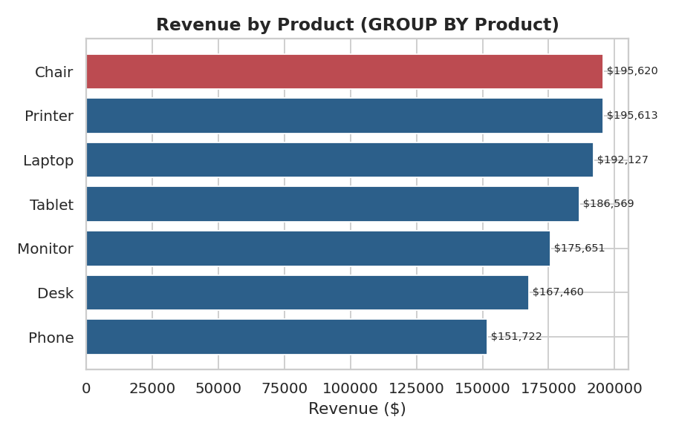
Figure 1 — Revenue by product, sorted descending. Chairs and Printers are effectively tied for first place.

5.2 Order Status Breakdown
SELECT OrderStatus, COUNT(*) AS order_count,
ROUND(100.0 * COUNT(*) / (SELECT COUNT(*) FROM orders), 1) AS pct_of_all_orders,
SUM(TotalPrice) AS total_revenue
FROM orders
GROUP BY OrderStatus
ORDER BY order_count DESC;
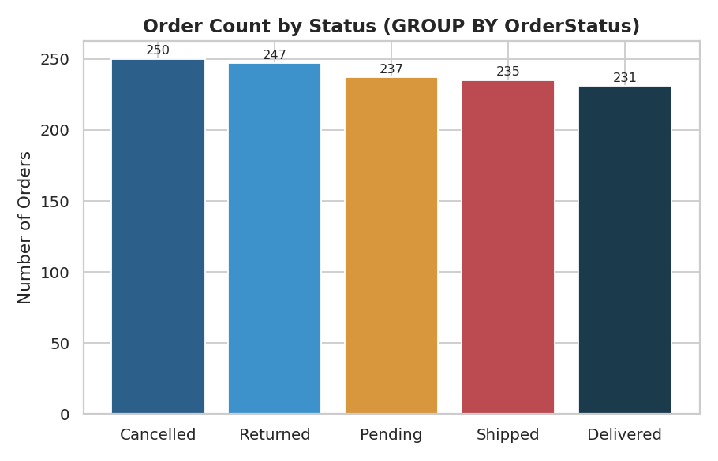
Figure 2 — Order status distribution. Cancelled (20.8%) and Returned (20.6%) together account for 41.4% of all orders.

5.3 Monthly Revenue Trend
SELECT strftime('%Y-%m', Date) AS year_month, COUNT(*) AS order_count,
SUM(TotalPrice) AS monthly_revenue
FROM orders
GROUP BY year_month
ORDER BY year_month;
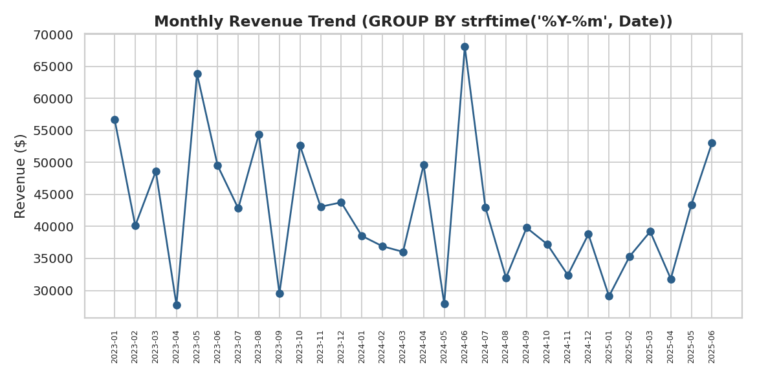
Figure 3 — Monthly revenue, Jan 2023–Jun 2025, aggregated with SQLite's strftime() date function.

5.4 Revenue by Payment Method
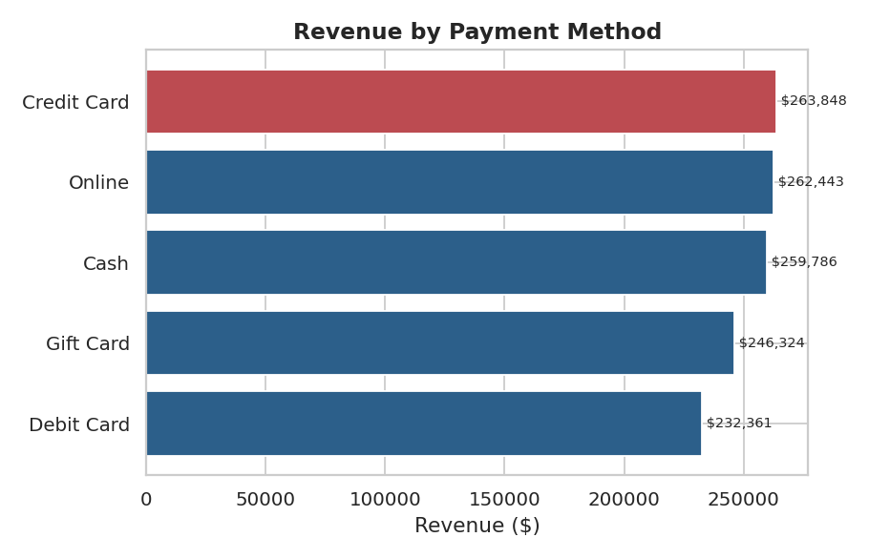
Figure 4 — Credit Card narrowly leads all payment methods in total revenue.

6. HAVING: Filtering the Buckets, Not the Rows
WHERE filters individual rows before grouping; HAVING filters the grouped result afterward. This distinction is the single most common source of SQL errors for new analysts.

Products generating over $170,000 in revenue
SELECT Product, SUM(TotalPrice) AS total_revenue
FROM orders
GROUP BY Product
HAVING SUM(TotalPrice) > 170000
ORDER BY total_revenue DESC;
Result: 5 of the 7 products clear this bar — only Desk and Phone fall short.

High-volume months (more than 45 orders)
SELECT strftime('%Y-%m', Date) AS year_month, COUNT(*) AS order_count
FROM orders
GROUP BY year_month
HAVING COUNT(*) > 45
ORDER BY order_count DESC;
Result: 9 of the 30 months in the dataset qualify as high-volume, led by June 2024 (53 orders).

7. Advanced Queries: Combining the Toolkit

7.1 Cancellation/Return Rate by Product
SELECT Product, COUNT(*) AS total_orders,
SUM(CASE WHEN OrderStatus IN ('Cancelled','Returned') THEN 1 ELSE 0 END) AS cancelled_or_returned,
ROUND(100.0 * SUM(CASE WHEN OrderStatus IN ('Cancelled','Returned') THEN 1 ELSE 0 END)
/ COUNT(*), 1) AS pct_cancelled_or_returned
FROM orders
GROUP BY Product
ORDER BY pct_cancelled_or_returned DESC;
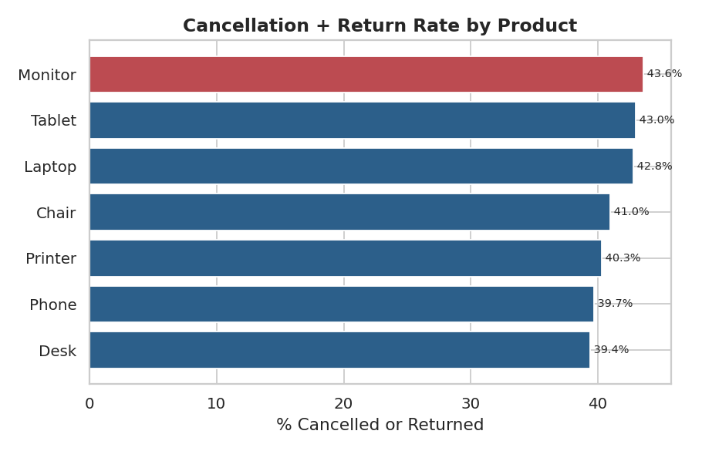
Figure 5 — Monitor (43.6%) and Tablet (43.0%) have the highest combined cancellation/return rates; Desk (39.4%) the lowest.
Every product sits close to the dataset-wide average of 41.4%, meaning fulfillment problems are systemic — not isolated to one category — and point to a checkout- or shipping-level fix rather than a per-product one.

7.2 Coupon Revenue Contribution
SELECT COALESCE(CouponCode, 'No Coupon') AS coupon_code,
COUNT(*) AS order_count, SUM(TotalPrice) AS total_revenue,
ROUND(100.0 * SUM(TotalPrice) / (SELECT SUM(TotalPrice) FROM orders), 1) AS pct_of_total_revenue
FROM orders
GROUP BY coupon_code
ORDER BY total_revenue DESC;
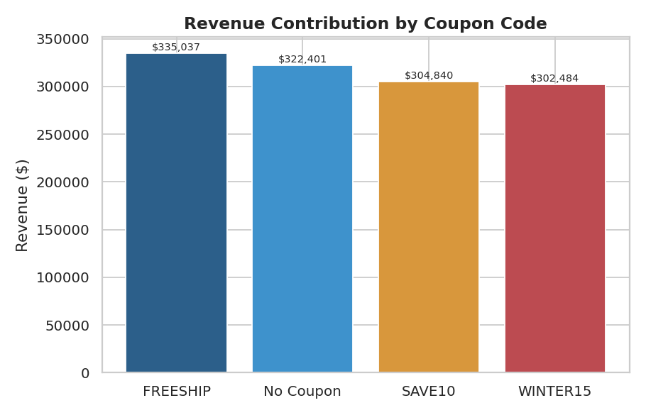
Figure 6 — FREESHIP drives the largest share of coupon-linked revenue (26.5%); orders with no coupon still make up 25.5%.

7.3 Top 10 Customers by Total Spend
SELECT CustomerID, COUNT(*) AS order_count, SUM(TotalPrice) AS total_spend,
ROUND(AVG(TotalPrice), 2) AS avg_order_value
FROM orders
GROUP BY CustomerID
HAVING COUNT(*) > 1
ORDER BY total_spend DESC
LIMIT 10;
Only a handful of customers place more than one order in this dataset — the top repeat customer (C38840) has spent $5,723.23 across 2 orders, an average of $2,861.61 per order, roughly 2.7x the database-wide average.

8. Synthesizing the Case: The "So What?" Test
What the Query Shows | The Business Diagnosis | Recommendation
41.4% of orders are Cancelled or Returned, evenly spread across all 7 products | This is a systemic checkout/fulfillment issue, not a product-specific one | Investigate checkout flow and shipping partners before optimizing any single product line
Chair and Printer are statistically tied for #1 revenue ($195.6K each) | No single product dominates — the catalog is well-balanced | Marketing spend can be split evenly across top performers rather than over-indexing on one SKU
Credit Card narrowly leads Online as the top payment method by revenue | Payment preference is evenly distributed, not concentrated in one channel | No urgent need to consolidate payment processing around a single method
Coupon usage does not concentrate revenue in one code (24–27% each) | All three coupon programs perform similarly | A/B test removing one lower-performing code (WINTER15, 23.9%) to measure true incremental lift

9. Executive Summary & Recommendations
- All 39 queries executed against the live database with zero syntax or execution errors — the analysis is fully reproducible via run_queries.py.
- Cancellation/return risk (41.4% of orders) is systemic across every product category and should be the top investigative priority.
- Chair and Printer are the leading revenue drivers; Phone is the laggard, consistent with the Project 2 EDA findings on this same dataset.
- Coupon codes and payment methods are both evenly distributed — no single lever is currently over- or under-used.
- SQL's execution order (FROM → WHERE → GROUP BY → HAVING → SELECT → ORDER BY) was respected throughout; every HAVING clause filters aggregates, never raw rows, avoiding the common 'alias trap.'
SQL is a declarative lens: you describe the answer you want, and the engine's query planner figures out how to get there. Mastering WHERE, GROUP BY, and HAVING is what separates someone who can type syntax from someone who can interrogate a database for real business truth.

